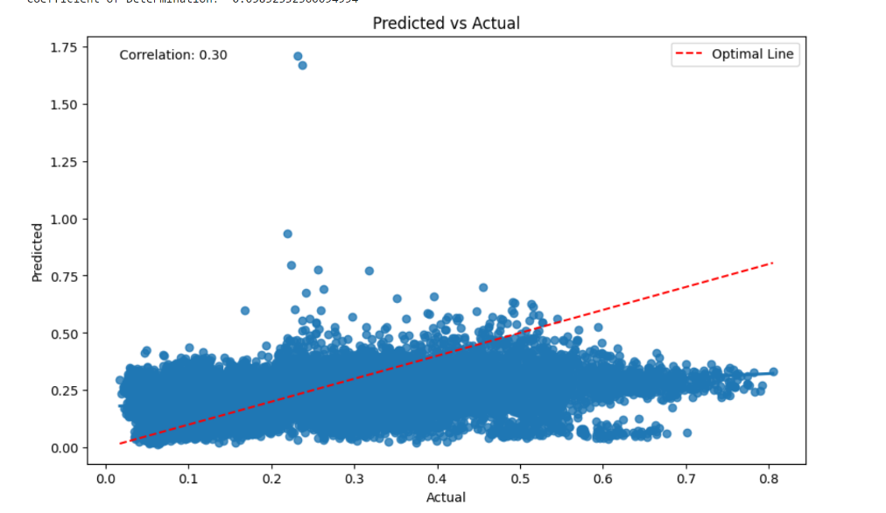Leaky relu plus soft



Just using softplus

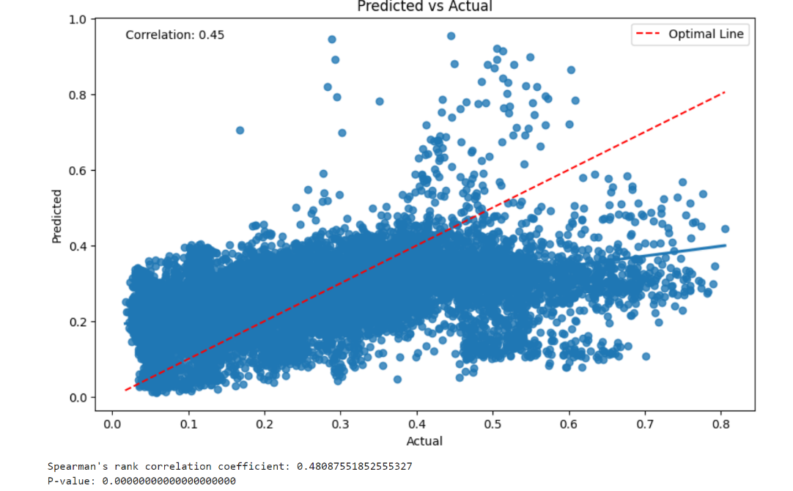

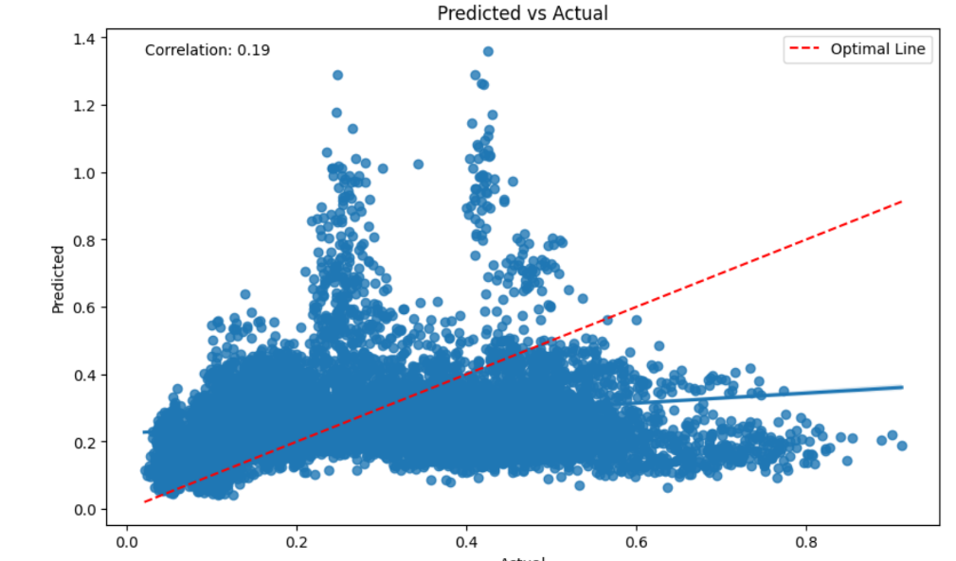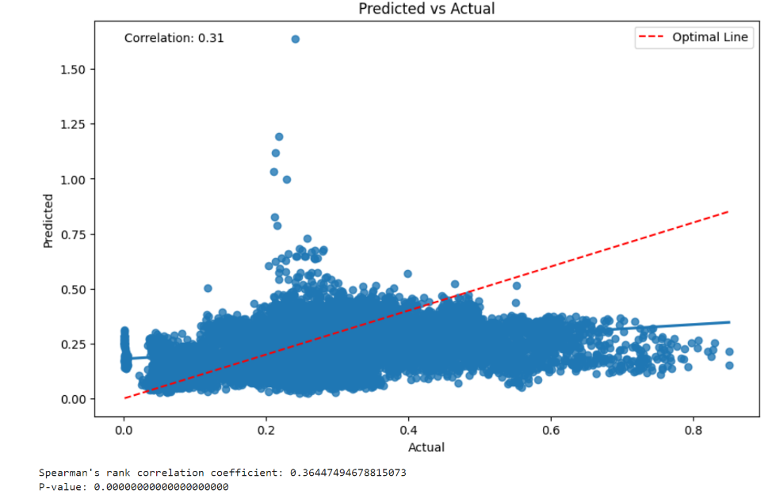new architecture leaky soft plus

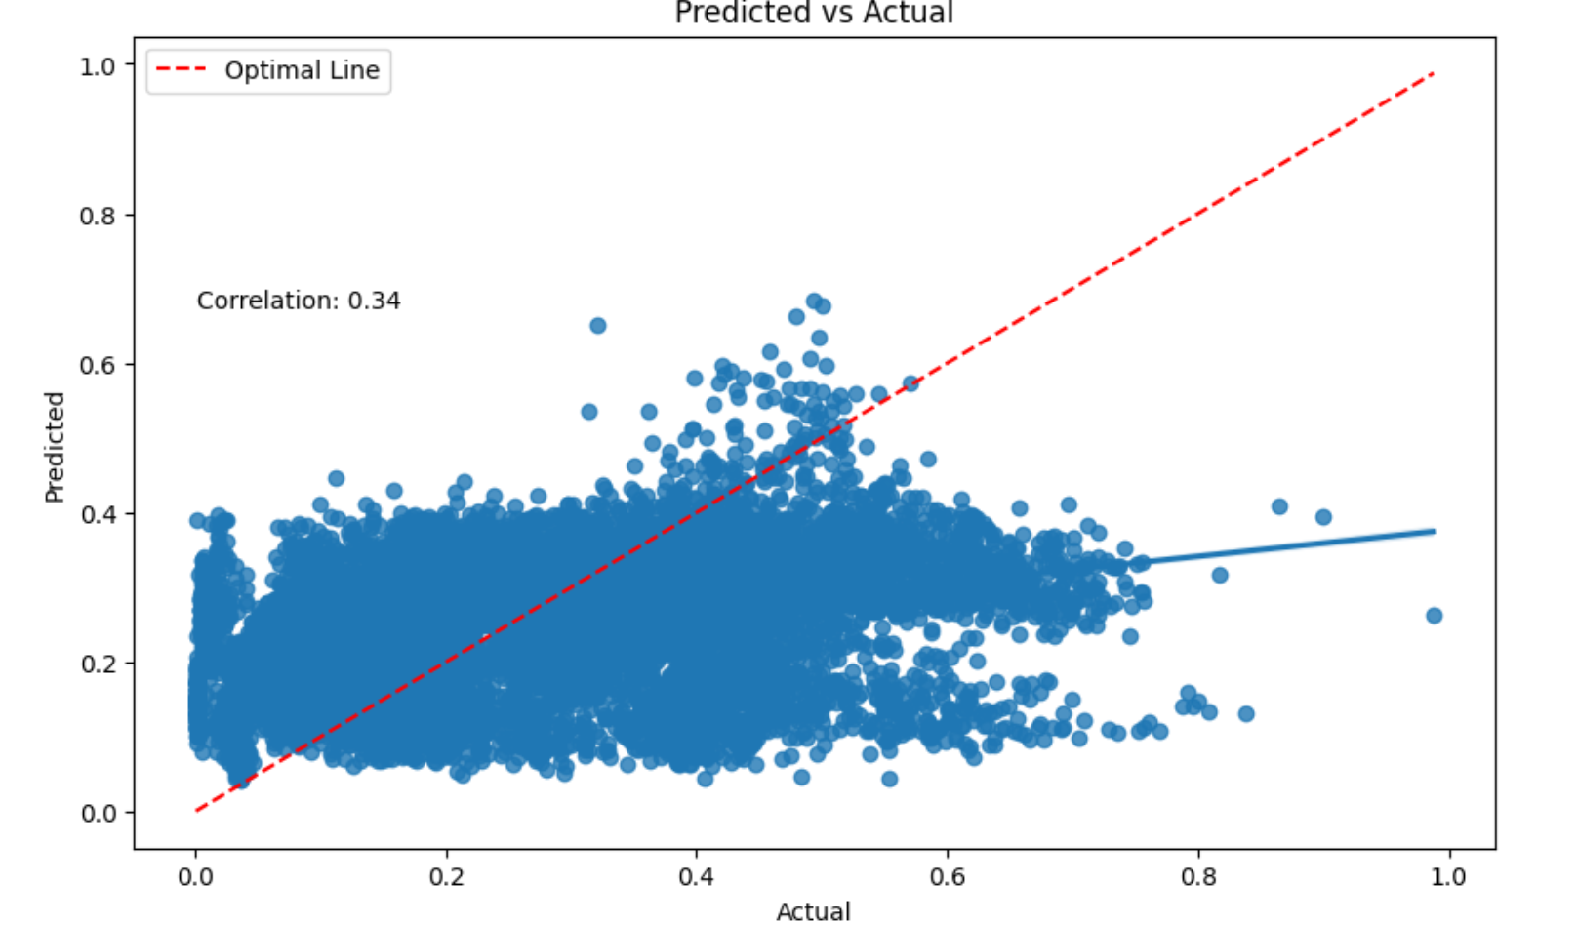

New architecture soft plus only